SUBTASK AND MILESTONE
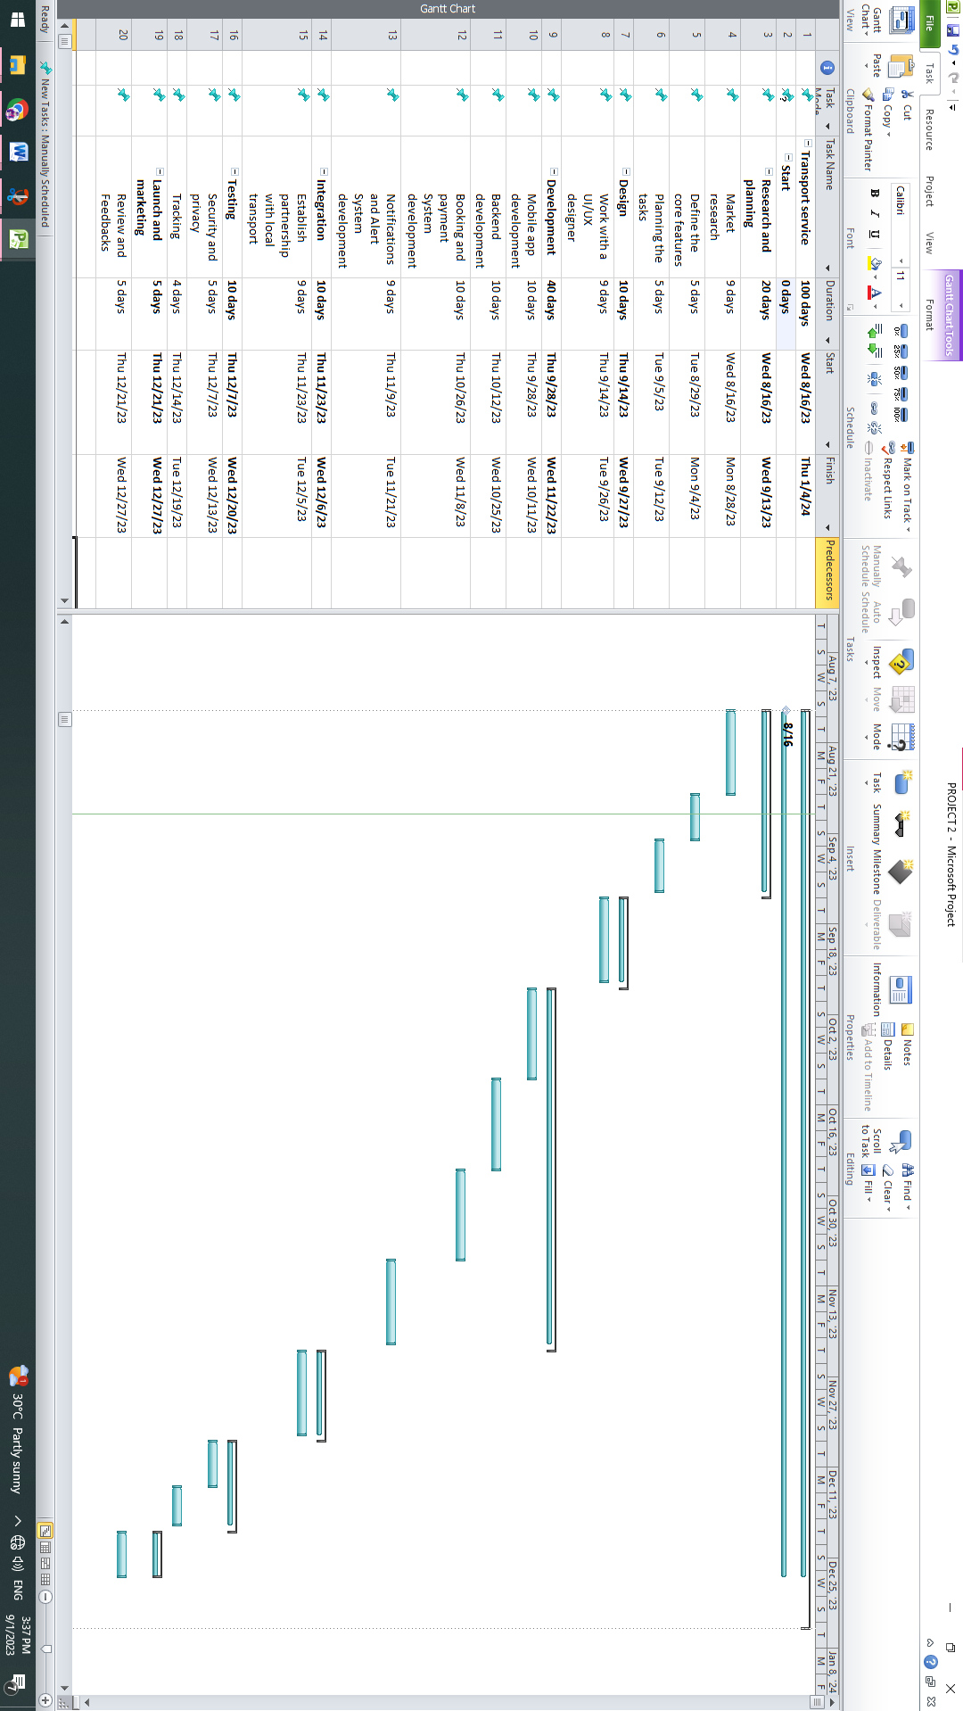

WORKING AND NON-WORKING DAYS
